**21 Lifestyle Hacks That Will Help Save You Money and Still Enjoy Life**

## 1. Eat At Home More Often

## 2. Walk To The Grocery Store

## 3. Start The Day With Lemon Water

## 4. Choose Brown Bread Instead Of White

## 5. Take Cold Showers

## 6. Add Spinach To Your Smoothies

## 7. Take The Stairs

## 8. Include Protein At Each Meal

## 9. Eat Or Drink Something Fermented

## 10. Sleep Seven Hours

## 11. Take Vitamin D Supplements

## 12. Swap To Green Tea For Your First Cup Of Coffee

## 13. Start Running

## 14. Use Smaller Plates For Portion Control

## 15. Roast Your Veggies

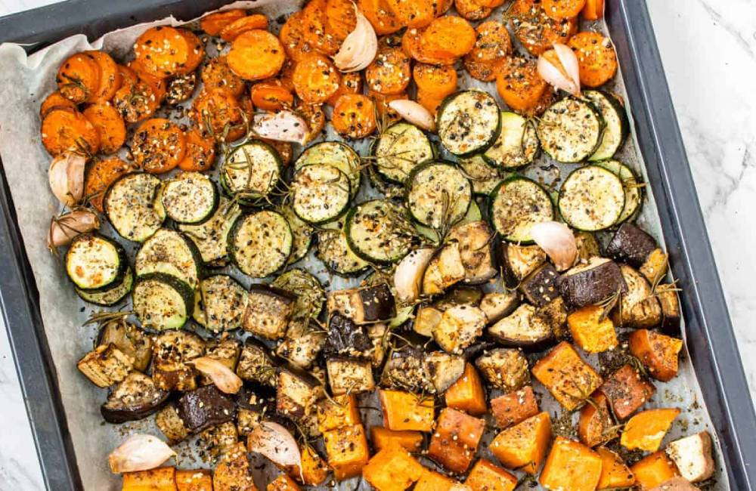

## 16. Make Meat A Treat



## 17. Try A Free Workout

## 18. Keep Prepared Fruit & Veg In The Fridge